- Download the Ivanti Secure Access client installation file from the following link:
for windows 32
for windows 64
- Install Ivanti Secure Access client
The download should start automatically. If not, click Run.
* If the installation window does not open, press ctrl+J and in the window that opens, click on the top link:
The following installation screen will open, click Next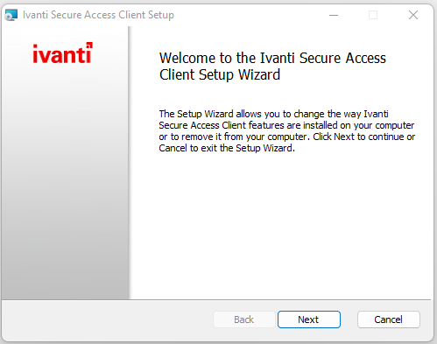
The following screen will open:

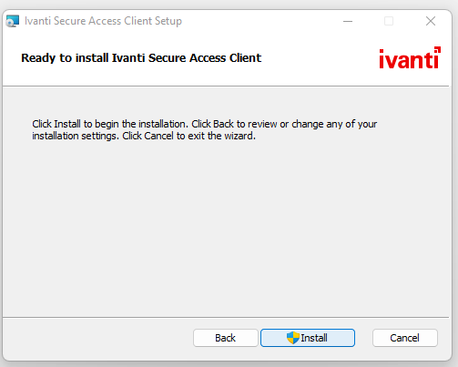
Click on Install, and wait for the installation to complete: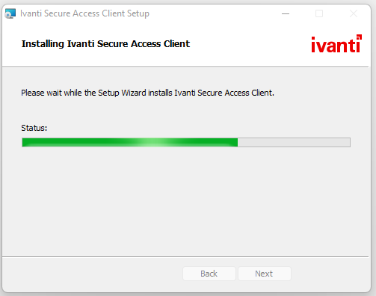
At the end of the installation we will get the following screen:
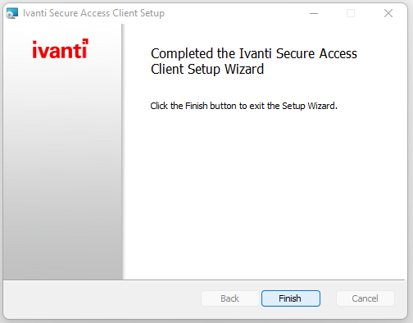
Click on Finish.

3. Activating the connection on the computer: search for Ivanti in the search bar on the computer:
לחצו על Open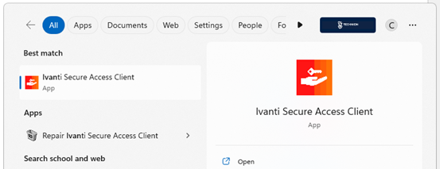

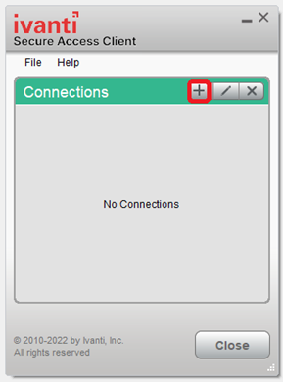
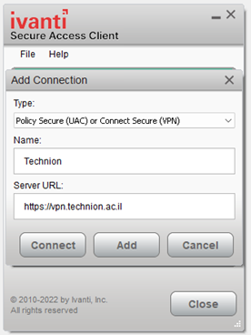
- Fill in the connection details as follows: In the Type line: there is no need to touch
In the Name line: write Technion
In the URL line: enter https://vpn.technion.ac.il

Click connect and identify with Technion account:

