My Semester in Taiwan – Irad Yoseph

Almost two years ago, I received an email inviting me to enroll in the Technion's student exchange program. I received this email while on reserve duty, roughly a month after the war started. At that time, an exchange program was probably the last thing on my mind. However, this opportunity simply would not leave my mind. Living abroad was a dream of mine. I've traveled to many countries before, but never got to experience a place as something other than a tourist.
So, rather impulsively, I decided to enroll. This was a one-time opportunity, and I could not afford to lose it - no matter the circumstances. As my destination I choose the furthest away location I could – Taiwan. I heard good things about Taiwan, and I wanted to experience a culture as different from mine as possible. So – I chose Taiwan and enrolled to the program.
I think my semester in Taiwan met all my expectations. I encountered so many kind and welcoming people, visited so many interesting places, and got live on other side of the planet for a few months.
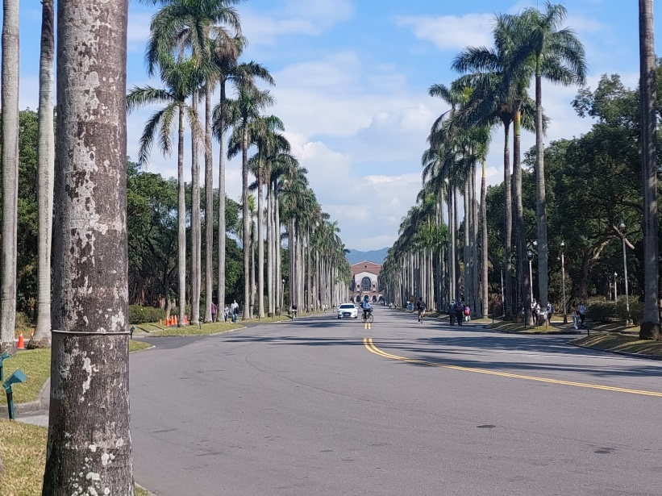
The main street at NTU campus

Each exchange student had their way of making the most out this semester – for me, it was a mixture of traveling the country, meeting new people from around the world and experiencing the Taiwanese culture. All of those proved to be much easier than I expected – Taiwan is a beautiful country that is very convenient, the locals are very happy to help you with anything you might need, or just to have a random conversation, and it was relatively easy to make friends among the exchange students.
I think that roughly knowing what your goals are in an exchange is a key part of making the most of it. Having those goals in mind – of seeing as much as I can and meeting many different people – I knew that I had to take a small number of courses compared to a regular semester at the Technion.
The first week, as expected, was a challenging one. Jetlagged and tired, I had to handle bureaucracy, to buy furniture for my room, get to know my new environment and try and make new friends. I recommend other exchange students to get to their home universities a week or so before the semester starts. Due to conflicting schedules, I arrived just a few days before the semester started, and that really not optimal.
Regarding the courses I took at NTU, I can say that the general kindness of the Taiwanese towards foreigners was also evident in my professors and teacher's assistants. They were generally quite patient and responsive. However, I must note that after 5 semesters at the Technion, studying at another place is challenging. Each university has its own method of teaching, and the one at NTU different in many ways from the Technion's method. I think getting to know local students from my faculty helped a lot in studying, and I would recommend future exchange students to do so as well, either through a buddy program or while attending the lectures. Unlike here at the Technion, where I know a lot of people from my faculty, most of my friends during the exchange were other exchange students, and very few of were engineering students, let alone from my faculty.
After settling in, my everyday in Taipei went relatively smoothly. I was very pleased with my dorms, which were spacious and in a good location. I think that Taipei is relatively easy city to adapt to. Street food is abundant and cheap, transportation – by metro or by bike – is very convenient, and the city has a certain charm I love very much. It felt at home very fast in Taipei and in my dorms. I hope any other future exchange student to Taipei will feel the same.
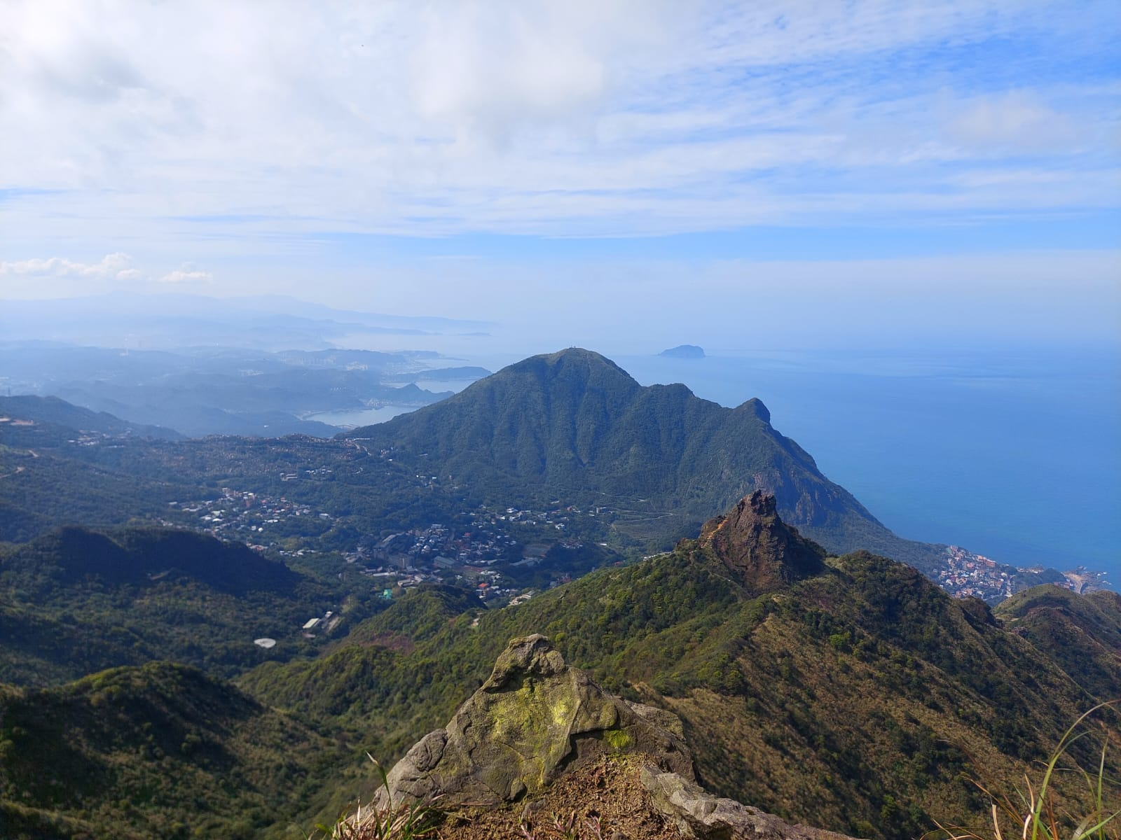
Like I said before, traveling the country was one of my main goals this semester. Taiwan is a tropical country, not very far away from the Philippines. Once you step out of the cites, you are surrounded by green. This combined with the ocean view makes Taiwan a really beautiful country, that I enjoyed traveling. It is small country, roughly 1.5 times the size of Israel, so traveling is convenient. Trains circle around coastline of the country and reach all the major cities.
Teapot Mountain

After enrolling in the program, I had many doubts. I was worried about all the difficulties I might face there, and whether this was worth the time and effort. I knew that I could withdraw from the program, and delayed having the final decision for about year. Meanwhile, the semesters kept progressing one after another (despite ongoing war), and I was no closer to a decision.
Finally, two months before the beginning of the exchange I came to the realization that I must participate in this exchange. This was a chance to fulfill my dream of living abroad, and to do so without having to worry about work or future plans.
I took a long pause from my regular life – the courses at the Technion, its stressful routine, its difficult exams, and the crazy situation in Israel. I think this long pause was exactly what I needed at that time.
And to those who have doubts, just like I did, I have one word of advice:
Go.

Irad Yoseph, September 2025
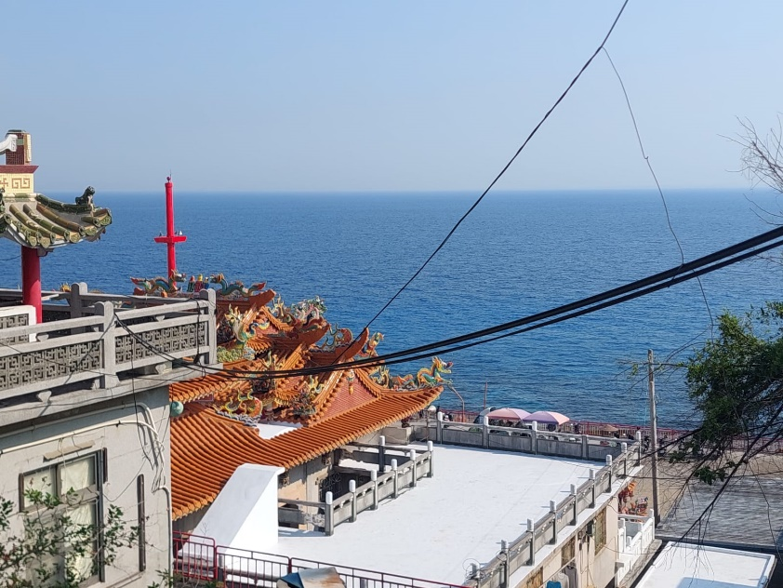
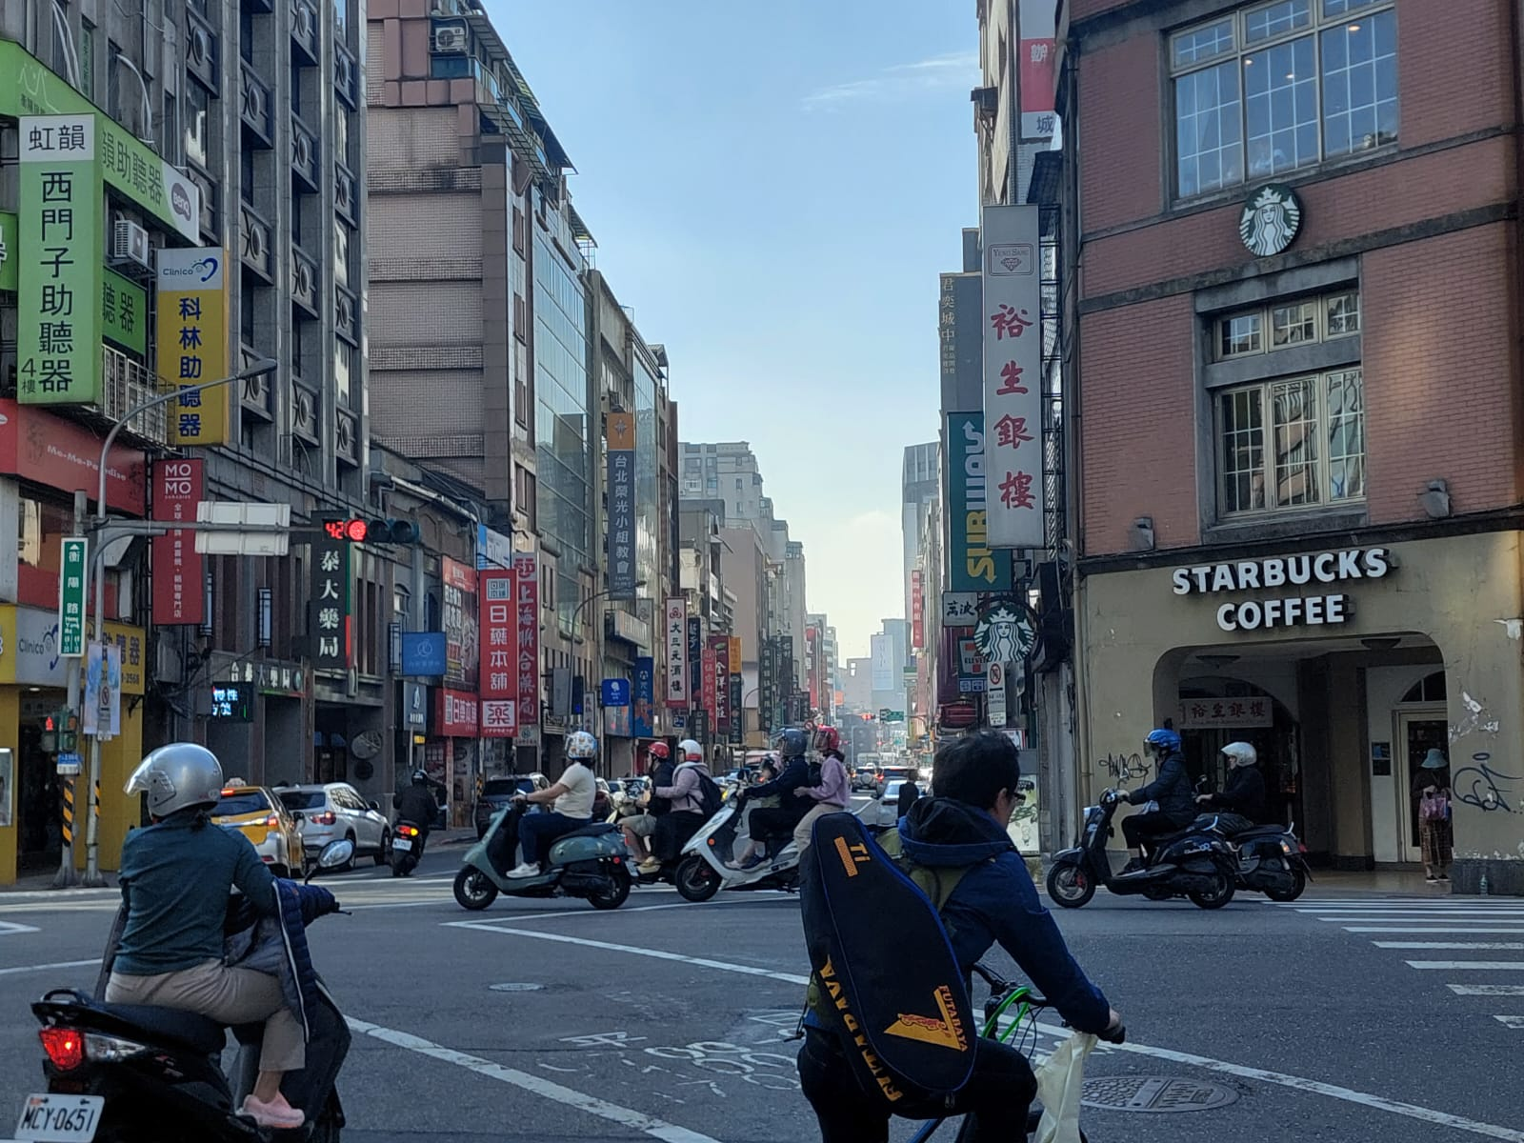
Typical street in Taipei

Temple in Lambai Island
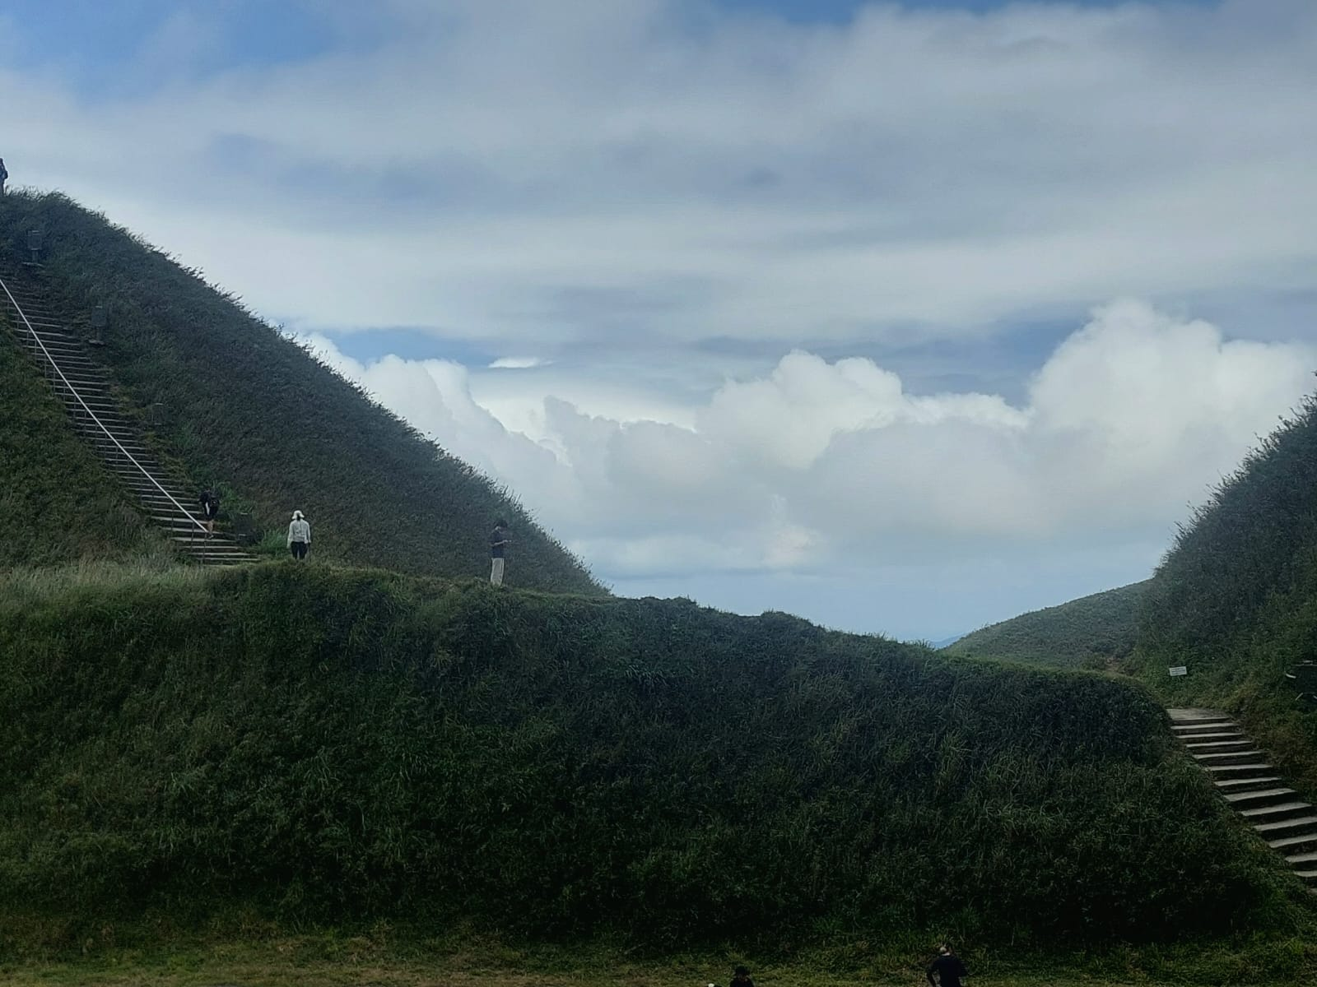
Near the peak of Match Mountain
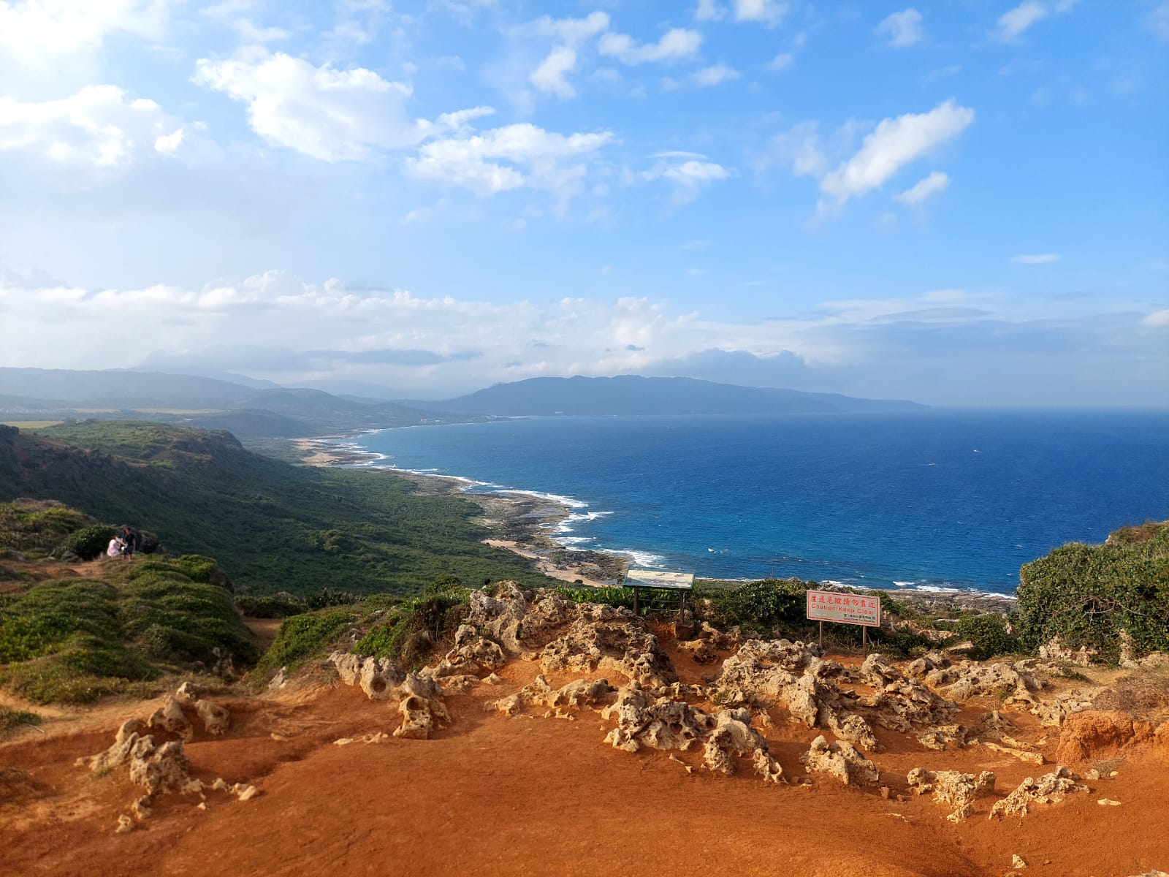
Near Kenting

